The small size of these vehicles enables them to operate indoors in constrained spaces.  
This capability will be particularly useful in dangerous situations such as searching for  
survivors in damaged buildings, entering and clearing buildings with armed adversaries,  
and collecting information in buildings with biological or nuclear contamination. In these  
scenarios the ability to create situational awareness without ever having to put a human in  
harm’s way is extremely valuable.

**Modeling and Control**

Many quadrotor controllers operate near hover and rely on small angle assumptions for  
roll and pitch. during the large angle  
portion of these trajectories there is no position control [33, 54, 56] or position control  
is not precise enough for obstacle avoidance [9]. Here we describe a control law that is  
sufficient for small angle flight and a control law for large pitch and roll angles for the  
purpose of controlling precisely along aggressive trajectories.

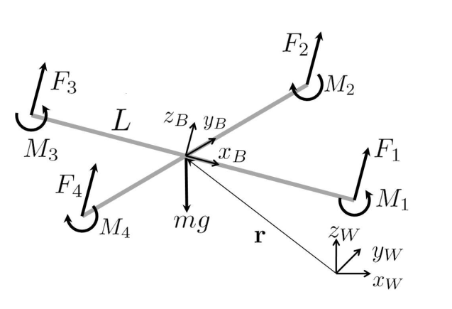

Rotor1 on positive x axis ,2 on the positive yB-axis, 3 on the negative xB-axis, 4 on the negative yB-axis. We use  
Z - X - Y Euler angles to model the rotation of the quadrotor in the world frame.

We use  
*Z - X - Y* Euler angles to model the rotation of the quadrotor in the world frame. To  
get from *W* to *B*, we first rotate about *zW* by the yaw angle, , then rotate about the  
intermediate *x*-axis by the roll angle, *φ*, and finally rotate about the *yB* axis by the pitch  
angle, *θ*. The rotation matrix for transforming coordinates from *B* to *W* is given by

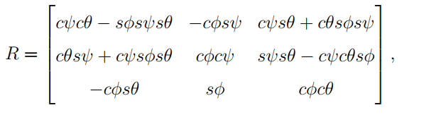

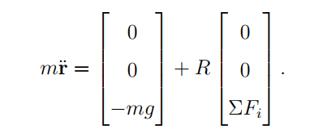

In addition to forces, each rotor produces a moment perpendicular to the plane of rotation  
of the blade, *Mi*. Rotors 1 and 3 rotate in the *-zB* direction while 2 and 4 rotate in the  
*zB* direction. Since the moment produced on the quadrotor is opposite to the direction of  
rotation of the blades, *M*1 and *M*3 act in the *zB* direction while *M*2 and *M*4 act in the *-zB*direction. We let *L* be the distance from the axis of rotation of the rotors to the center of  
the quadrotor. The moment of inertia matrix referenced to the center of mass along the  
*xB - yB - zB* axes, *I*, is found by weighing individual components of the quadrotor and  
7  
building a physically accurate model in SolidWorks. The angular acceleration determined  
by the Euler equations is

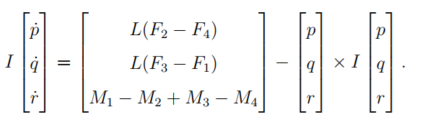

**Motor Model**

